Git link : https://github.com/EMGPPT/prog7311-g3-2026-part-2-ST10443092
Video link: https://youtu.be/IC33EfmXktc
**Should the link not work the vide will also be uploaded

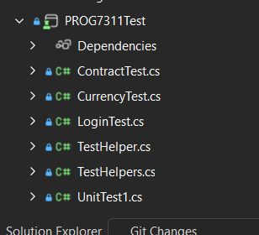

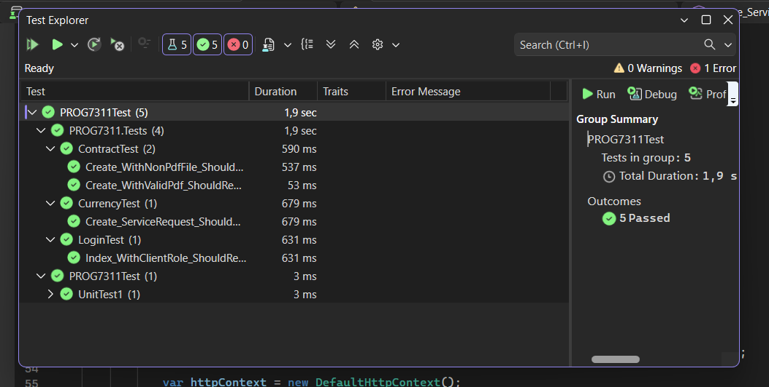

DATABASE Migration + Script

Note, it is important you don’t have a database named “PROG7311Db”, if you do there will be conflicts with the entities.

Option 1 (fastest)
Open Program, navigate to the “Package Manager Console” and run these commands:
Add-Migration Initialcreate
Update-Database
*(if an error message returns “migration with InitialCreate already exists” change the InitialCreate to anything else)*
Then the program will be ready to run
Login accounts already seeded:
Admin
username: admin
password: admin
Client
username: client
password: client

Option 2
🧭 Entity Framework Migration & Database Update Guide
Step-by-Step Instructions
- Open a Terminal or Command Prompt
  - Navigate to the folder where the project’s .csproj file is located.
  - Example file path:
  - C:\Users\Qhawe\Documents\GitHub\prog7311-g3-2026-part-2-ST10443092\PROG7311
  - In the terminal, run:
  - cd "C:\Users\lab_services_student\Desktop\bcad2-prog6212-part-2-submission-ST10443092-main\PROGP2\PROGP2".

- Run the Migration
  - Command:
  - dotnet ef migrations add Initialcreate

- Update the Database
  - Apply the migration to create or update the database schema.
  - Command:
  - dotnet ef database update

- Project Ready to Run
  - Once the database update completes successfully, the project should be fully set up and ready to run
Login accounts already seeded:
Admin
username: admin
password: admin
Client(Would recommend you create your own Client profile)
username: client
password: client

Alternative option

Use this only If the first two options didn’t work.
- Open SQL Server Management Studio
- Run this script
- Database PROG7311Db is created
- Run your MVC project
Login accounts already seeded:
Admin
username: admin
password: admin
Client
username: client
password: client

-- ================================
-- PROG7311 DATABASE SCRIPT
-- ================================

IF DB_ID('PROG7311Db') IS NULL
BEGIN
CREATE DATABASE PROG7311Db;
END
GO

USE PROG7311Db;
GO

-- Drop tables if they exist (dependency order)
IF OBJECT_ID('ServiceRequests','U') IS NOT NULL DROP TABLE ServiceRequests;
IF OBJECT_ID('Users','U') IS NOT NULL DROP TABLE Users;
IF OBJECT_ID('Contracts','U') IS NOT NULL DROP TABLE Contracts;
IF OBJECT_ID('Clients','U') IS NOT NULL DROP TABLE Clients;
GO

-- ================================
-- CLIENTS
-- ================================
CREATE TABLE Clients
(
ClientId INT IDENTITY(1,1) PRIMARY KEY,
Name NVARCHAR(MAX) NOT NULL,
ContactDetails NVARCHAR(MAX) NOT NULL,
Region NVARCHAR(MAX) NOT NULL
);
GO

-- ================================
-- CONTRACTS
-- ================================
CREATE TABLE Contracts
(
ContractId INT IDENTITY(1,1) PRIMARY KEY,
ClientId INT NOT NULL,
StartDate DATETIME2 NOT NULL,
EndDate DATETIME2 NOT NULL,
Status NVARCHAR(MAX) NOT NULL,
ServiceLevel NVARCHAR(MAX) NOT NULL,
SignedAgreement VARBINARY(MAX) NULL,

CONSTRAINT FK_Contracts_Clients
FOREIGN KEY (ClientId)
REFERENCES Clients(ClientId)
ON DELETE CASCADE
);
GO

CREATE INDEX IX_Contracts_ClientId
ON Contracts(ClientId);
GO

-- ================================
-- USERS
-- ================================
CREATE TABLE Users
(
UsersId INT IDENTITY(1,1) PRIMARY KEY,
Username NVARCHAR(MAX) NOT NULL,
Password NVARCHAR(MAX) NOT NULL,
Role NVARCHAR(MAX) NOT NULL,
ClientId INT NULL,

CONSTRAINT FK_Users_Clients
FOREIGN KEY (ClientId)
REFERENCES Clients(ClientId)
ON DELETE SET NULL
);
GO

CREATE INDEX IX_Users_ClientId
ON Users(ClientId);
GO

-- ================================
-- SERVICE REQUESTS
-- ================================
CREATE TABLE ServiceRequests
(
ServiceRequestId INT IDENTITY(1,1) PRIMARY KEY,

ClientId INT NOT NULL,
ContractId INT NOT NULL,

Description NVARCHAR(MAX) NOT NULL,

Cost DECIMAL(18,2) NOT NULL,

CostCurrencyCode NVARCHAR(3) NOT NULL,

CostInZar DECIMAL(18,2) NOT NULL,

ExchangeRateToZar DECIMAL(18,6) NOT NULL,

CurrencyRateDate DATE NULL,

CurrencyConvertedAtUtc DATETIME2 NULL,

Status NVARCHAR(MAX) NOT NULL,

CONSTRAINT FK_ServiceRequests_Client
FOREIGN KEY (ClientId)
REFERENCES Clients(ClientId)
ON DELETE NO ACTION,

CONSTRAINT FK_ServiceRequests_Contract
FOREIGN KEY (ContractId)
REFERENCES Contracts(ContractId)
ON DELETE CASCADE
);
GO

CREATE INDEX IX_ServiceRequests_ClientId
ON ServiceRequests(ClientId);

CREATE INDEX IX_ServiceRequests_ContractId
ON ServiceRequests(ContractId);
GO

-- ================================
-- SEED DATA (matches EF snapshot)
-- ================================

INSERT INTO Users (Username,Password,Role)
VALUES
('client','client','Client'),
('admin','admin','Admin');
GO

